*Supplementary information:*

**Landuse affects the likelihood of soil colonization by a key plant pathogen**

Rebecca Lyons1, Anna-Belle C. Clarke1, Hazel R. Lapis-Gaza2, Jiarui Sun1, Henry W. G. Birt1†, Anthony B. Pattison1,2, Paul G. Dennis1*

*1School of the Environment, The University of Queensland, Turrbal Country, Brisbane, QLD 4072, Australia; 2Department of Agriculture and Fisheries, Centre for Wet Tropics Agriculture, 24 Experimental Station Road, South Johnstone, QLD 4859, Australia;* \**Correspondence*: [p.dennis@uq.edu.au](mailto:p.dennis@uq.edu.au); *†Current address: Department of Earth and Environmental Sciences, The University of Manchester, Manchester, UK.*

*Content:*

**Table S1** Sample locations and landuse classification………………………….….……………..2

**Table S2** Land area assigned to landuses bordering banana……………………………....…3-4

**Table S3** Impacts of treatment on *Foc* colonization………………………………………..…...5-6

**Fig. S1** *Foc* abundance in Mock and *Foc* inoculated soils……………………………….………..7

**Table S4** Impact of landuse on Δ*Foc*………………………………………………..………………8

**Fig. S2** Impact of landuse on Δ*Foc* in sterilized soils……………………………..…………….....9

**Table S5** OTUs associated with differences between landuses…………………..………..10-12

**Table S1** Landuse and geographical coordinates for each site surveyed. QLUMP: Queensland Landuse Mapping Programme.

|  |  |  |  |  |
| --- | --- | --- | --- | --- |
| **Landuse designation**  **(Birt et al., 2024)** | **QLUMP landuse designation** | **QLUMP category level** | **Latitude** | **Longitude** |
| Banana | Irrigated tree fruits, commodity: bananas | Tertiary, Commodity | -17.571 | 146.0286 |
| Banana | -17.546 | 145.9516 |
| Banana | -17.598 | 146.0116 |
| Banana | -17.559 | 145.9181 |
| Banana | -17.722 | 145.927 |
| Banana | -17.614 | 146.0172 |
| Banana | -17.613 | 145.9057 |
| Banana | -17.609 | 145.8697 |
| Sugarcane | Sugar | Tertiary | -17.73 | 146.0623 |
| Sugarcane | -17.592 | 145.9517 |
| Sugarcane | -17.612 | 145.9919 |
| Sugarcane | -17.706 | 146.025 |
| Sugarcane | -17.698 | 146.0721 |
| Sugarcane | -17.756 | 145.9836 |
| Sugarcane | -17.699 | 146.0896 |
| Sugarcane | -17.49 | 146.0174 |
| Rainforest | National park, managed resource protection, residual native cover | Tertiary | -17.716 | 145.8619 |
| Rainforest | -17.754 | 145.9378 |
| Rainforest | -17.611 | 145.8019 |
| Rainforest | -17.523 | 146.0647 |
| Rainforest | -17.66 | 145.7806 |
| Rainforest | -17.612 | 145.8681 |
| Rainforest | -17.79 | 145.9558 |
| Rainforest | -17.663 | 145.8723 |
| Grassland | Grazing native vegetation | Tertiary | -17.746 | 145.9667 |
| Grassland | -17.491 | 146.0213 |
| Grassland | -17.718 | 145.8872 |
| Grassland | -17.616 | 145.9089 |
| Grassland | -17.406 | 145.9955 |
| Grassland | -17.709 | 146.009 |
| Grassland | -17.717 | 145.9096 |
| Grassland | -17.507 | 145.9742 |

**Table S2** Area assigned to landuses bordering banana polygons by 100 meters in the Wet Tropics region of North Queensland, Australia. The labels within ‘Landuse’ are the Queensland Landuse Mapping Programme (QLUMP) tertiary designations with commodities listed in parenthesis where appropriate. The labels in ‘Classification’ are the landuse classifications used in the present study, based on Table S1.

|  |  |  |  |
| --- | --- | --- | --- |
| **Landuse** | **Area (Hectares)** | **Area (%)** | **Classification** |
| Grazing native vegetation | 3562.33 | 26.60 | Grassland |
| Residual native cover | 3099.03 | 23.14 | Rainforest |
| Sugar | 3075.18 | 22.96 | Sugar |
| Irrigated tree fruits (bananas) | 512.81 | 3.83 | Banana |
| River | 503.06 | 3.76 | Other |
| Rural residential with agriculture | 491.54 | 3.67 | Other |
| Marsh/wetland | 348.49 | 2.60 | Other |
| National park | 278.97 | 2.08 | Rainforest |
| Irrigated tree fruits | 255.65 | 1.91 | Other |
| Other minimal use | 214.37 | 1.60 | Other |
| Irrigated cropping | 157.06 | 1.17 | Other |
| Irrigated sugar | 120.32 | 0.90 | Other |
| Irrigated perennial horticulture | 87.29 | 0.65 | Other |
| Rural residential without agriculture | 71.63 | 0.53 | Other |
| Irrigated tree fruits (avocaods) | 71.40 | 0.53 | Other |
| Irrigated tree fruits (mangoes) | 44.59 | 0.33 | Other |
| Airports/aerodromes | 37.13 | 0.28 | Other |
| Urban residential | 35.06 | 0.26 | Other |
| Irrigated hay and silage | 32.88 | 0.25 | Other |
| Irrigated seasonal horticulture | 30.50 | 0.23 | Other |
| Food processing factory | 29.96 | 0.22 | Other |
| Softwood plantation forestry | 28.77 | 0.21 | Other |
| Reservoir/dam | 23.16 | 0.17 | Other |
| Other conserved area | 20.61 | 0.15 | Other |
| Irrigated land in transition | 19.45 | 0.15 | Other |
| Land in transition | 19.28 | 0.14 | Other |
| Aquaculture | 18.86 | 0.14 | Other |
| Hardwood plantation forestry | 17.27 | 0.13 | Other |
| Manufacturing and industrial | 17.08 | 0.13 | Other |
| Production native forests | 16.97 | 0.13 | Other |
| Plantation forests | 16.92 | 0.13 | Other |
| Farm buildings/infrastructure | 13.68 | 0.10 | Other |
| Quarries | 12.70 | 0.09 | Other |
| Grazing modified pastures | 11.06 | 0.08 | Other |
| Commercial services | 10.71 | 0.08 | Other |
| Intensive horticulture | 10.07 | 0.08 | Other |
| Research facilities | 9.46 | 0.07 | Other |
| Recreation and culture | 9.03 | 0.07 | Other |
| Irrigated tree nuts (macadamias) | 7.20 | 0.05 | Other |
| Irrigated beverage and spice crops | 6.25 | 0.05 | Other |
| River – conservation | 6.23 | 0.05 | Other |
| Grazing irrigated modified pastures | 6.01 | 0.04 | Other |
| Irrigated vine fruits | 5.85 | 0.04 | Other |
| Irrigated cereals | 5.54 | 0.04 | Other |
| Managed resource protection | 4.10 | 0.03 | Rainforest |
| Shadehouses | 3.71 | 0.03 | Other |
| Perennial horticulture | 2.90 | 0.02 | Other |
| Transport and communication | 1.76 | 0.01 | Other |
| Piggeries | 1.59 | 0.01 | Other |
| Public services | 1.33 | 0.01 | Other |
| Defence | 1.29 | 0.01 | Other |
| Poultry farms | 1.07 | 0.01 | Other |
| Land under rehabilitation | 1.06 | 0.01 | Other |
| Water extraction and transmission | 0.44 | 0.00 | Other |
| Defence facilities – urban | 0.42 | 0.00 | Other |
| Irrigated citrus | 0.04 | 0.00 | Other |
| Cropping | 0.03 | 0.00 | Other |
| Waste treatment and disposal | 0.00 | 0.00 | Other |
| Lake – saline | 0.00 | 0.00 | Other |

**Table S3** Results of afour-way mixed effects model investigating the main and interactive effects of Time (day 0 or day 28), Landuse (rainforest, grassland, sugarcane, banana), Sterility (non-sterilized or sterilized) and Inoculation (mock or *Foc*) on log-transformed *Fusarium oxysporum* f. sp. *cubense* (*Foc*) Race 1 copy numbers with site as a random effect. Three-way mixed effects models were undertaken on subsets of the data sorted according to Time (0 or 28 days), Inoculation (Mock or *Foc*) or Sterility (Non-sterilized and sterilized). Within each of these subsets, the main and interactive effects of each of the variables on log-transformed *Foc* copy numbers are shown. Asterisks represent the significance of model terms where: *p* < 0.001***; *p* < 0.01**; *p* < 0.05*.

|  |  |  |  |  |
| --- | --- | --- | --- | --- |
| **Data** | **Predictor** | ***F* value** | ***P* value** | |
| All | Time | 52.6 | <0.001 | *** |
|  | Landuse | 5.5 | 0.004 | ** |
|  | Sterility | 43.1 | <0.001 | *** |
|  | Inoculated | 160.0 | <0.001 | *** |
|  | Time : Landuse | 1.9 | 0.133 |  |
|  | Time : Sterility | 82.7 | <0.001 | *** |
|  | Landuse : Sterility | 2.3 | 0.082 | . |
|  | Time : Inoculated | 53.0 | <0.001 | *** |
|  | Landuse : Inoculated | 1.1 | 0.331 |  |
|  | Sterility : Inoculated | 70.1 | <0.001 | *** |
|  | Time : Landuse : Sterility | 2.7 | 0.049 | * |
|  | Time : Landuse : Inoculated | 3.3 | 0.020 | * |
|  | Time : Sterility : Inoculated | 76.2 | <0.001 | *** |
|  | Landuse : Sterility : Inoculated | 0.2 | 0.917 |  |
|  | Time : Landuse : Sterility : Inoculated | 1.0 | 0.393 |  |
|  |  |  |  |  |
| 0 days | Landuse | 1.0 | 0.417 |  |
|  | Sterility | 2.8 | 0.099 |  |
|  | Inoculated | 12.5 | <0.001 | *** |
|  | Sterility : Landuse | 0.7 | 0.547 |  |
|  | Landuse : Inoculated | 1.2 | 0.323 |  |
|  | Sterility : Inoculated | 0.1 | 0.815 |  |
|  | Sterility : Landuse : Inoculated | 0.2 | 0.866 |  |
|  |  |  |  |  |
| 28 days | Landuse | 6.7 | 0.002 | ** |
|  | Sterility | 148.9 | <0.001 | *** |
|  | Inoculated | 241.2 | <0.001 | *** |
|  | Sterility : Landuse | 5.0 | 0.003 | ** |
|  | Landuse : Inoculated | 3.8 | 0.013 | *** |
|  | Sterility : Inoculated | 177.5 | <0.001 | * |
|  | Sterility : Landuse : Inoculated | 1.1 | 0.360 |  |
|  |  |  |  |  |
| Mock | Time | 0.0 | 0.981 |  |
|  | Landuse | 1.7 | 0.191 |  |
|  | Sterility | 2.3 | 0.136 |  |
|  | Time : Landuse | 0.5 | 0.699 |  |
|  | Time : Sterility | 0.1 | 0.760 |  |
|  | Landuse : Sterility | 1.4 | 0.239 |  |
|  | Time : Landuse : Sterility | 0.4 | 0.724 |  |
|  |  |  |  |  |
| *Foc* | Time | 81.7 | <0.001 | *** |
|  | Landuse | 5.1 | 0.002 | ** |
|  | Sterility | 86.3 | <0.001 | *** |
|  | Time : Landuse | 3.8 | 0.013 | * |
|  | Time : Sterility | 123.0 | <0.001 | *** |
|  | Landuse : Sterility | 1.1 | 0.359 |  |
|  | Time : Landuse : Sterility | 2.6 | 0.056 | . |
|  |  |  |  |  |
| Non-sterilized | Time | 1.7 | 0.196 |  |
|  | Landuse | 5.4 | 0.004 | ** |
|  | Inoculated | 9.1 | 0.003 | ** |
|  | Time : Landuse | 3.6 | 0.017 | * |
|  | Time : Inoculated | 1.0 | 0.310 |  |
|  | Landuse : Inoculated | 1.0 | 0.407 |  |
|  | Time : Landuse : Inoculated | 4.0 | 0.011 | * |
|  |  |  |  |  |
| Sterilized | Time | 138.6 | <0.001 | *** |
|  | Landuse | 2.3 | 0.097 | . |
|  | Inoculated | 229.1 | <0.001 | *** |
|  | Time : Landuse | 1.0 | 0.403 |  |
|  | Time : Inoculated | 132.9 | <0.001 | *** |
|  | Landuse : Inoculated | 0.4 | 0.789 |  |
|  | Time : Landuse : Inoculated | 0.4 | 0.766 |  |

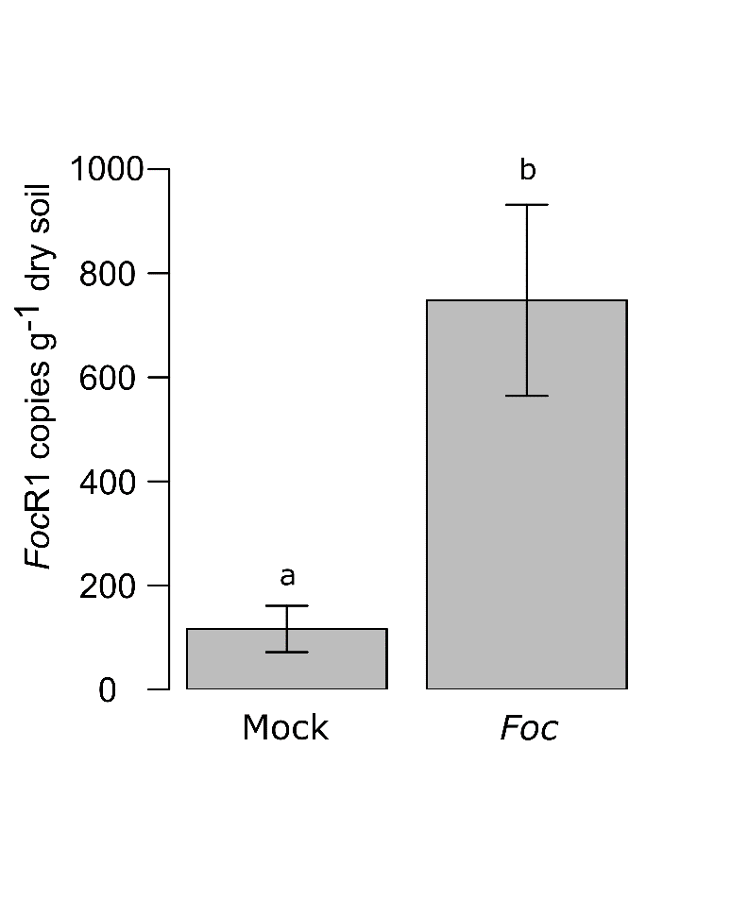

**Fig. S1** *Fusarium oxysporum* f. sp. *cubense* Race 1 (*Foc* R1) marker gene copy number at Day 0 in mock-inoculated (Mock) vs. *Foc*-inoculated (*Foc*) soils. Data shown are the mean and standard error for all Day 0 soils (n=64) per treatment. The letters above the bars represent the results of a Tukey’s Honest Significant Difference *post hoc* test applied to a one-way mixed effects ANOVA investigating the effect of inoculation on *Foc* copy number at Day 0, with site as the random effect, where treatments with the same letter cannot be shown to differ.

**Table S4** The impact of landuse on *Fusarium oxysporum* f. sp. *cubense* (*Foc*) soil colonization. Results are from generalised linear models (gaussian distribution) investigating the effects of landuse on Δ*Foc* (*Foc* Race 1 marker gene copy marker gene copies at Day 28 minus those at Day 0) in each treatment group. Asterisks represent the significance of model terms where: *p* < 0.001***; *p* < 0.01**; *p* < 0.05*.

|  |  |  |  |
| --- | --- | --- | --- |
| **Response variable** | ***F* value** | ***P* value** | |
| ∆*Foc*; Non-sterilized: Mock | 0.6 | 0.626 |  |
| ∆*Foc*; Non-sterilized: *Foc* | 6.6 | 0.002 | ** |
| ∆*Foc*; Sterilized: Mock | 1.6 | 0.221 |  |
| ∆*Foc*; Sterilized: *Foc* | 0.4 | 0.786 |  |

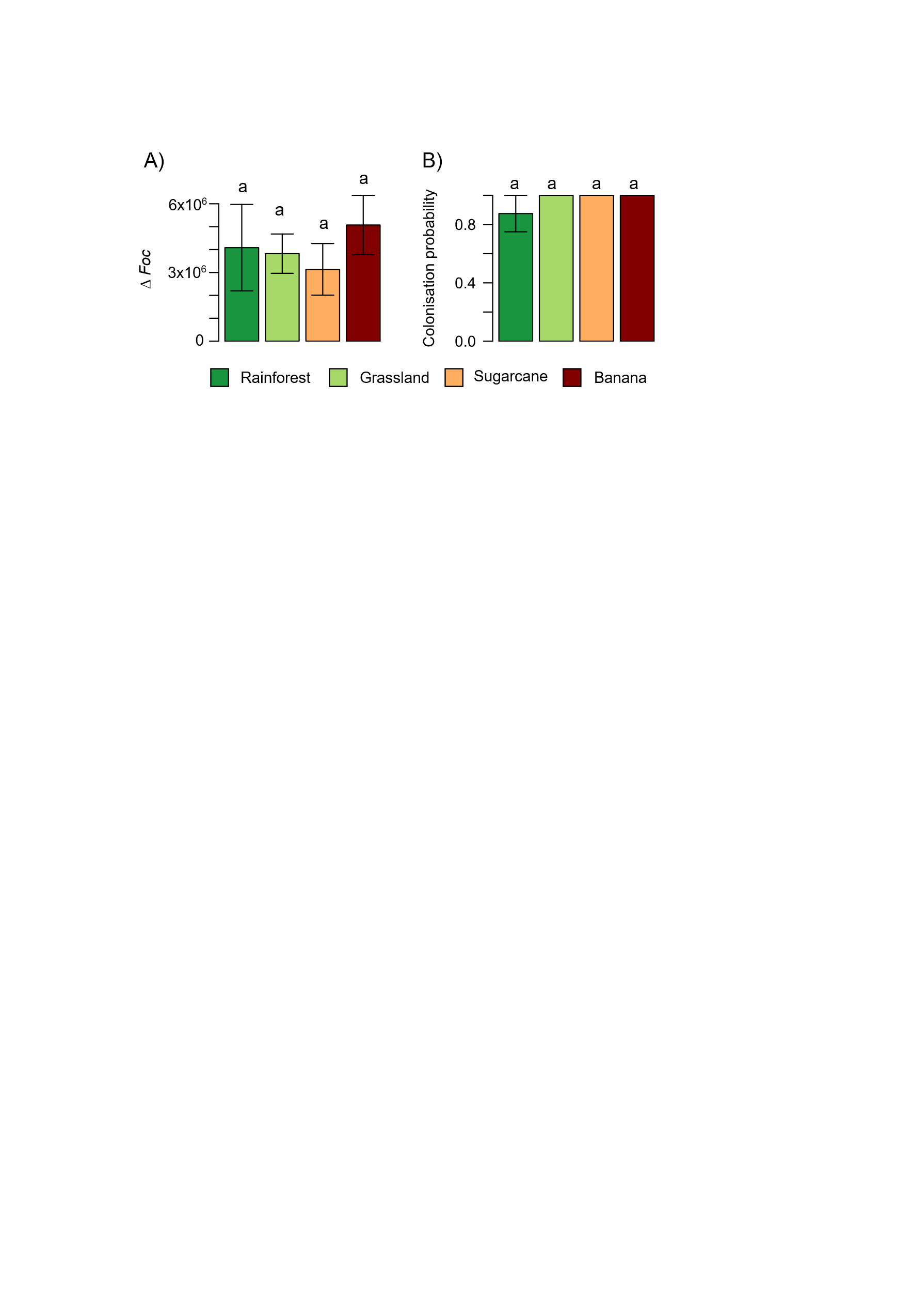

**Fig. S2** Impact of landuse on *Fusarium oxysporum* f. sp. *cubense* (*Foc*) soil colonization in sterilized soils**.** (A) *Foc* marker gene copy number between the start and end of the experiment (∆*Foc = Foc* R1 marker gene copies at Day 28 minus those at Day 0) in each landuse*.* (B) The probability of *Foc* colonization (∆*Foc* > 0) for each landuse. All results are for sterilized *Foc*-inoculated soils. Data shown for both graphs are the mean and standard error of eight sites within each landuse for each treatment. Letters above the bars represent the results of Tukey’s Honest Significant Difference *post hoc* tests, where treatments with the same letter cannot be shown to differ.

**Table S5** Lists of bacterial and fungal operational taxonomic units (OTUs) associated with banana. Shown are the OTUs with the 10 largest (negatively associated with banana) and 10 smallest (positively associated with banana) primary and secondary axis scores from distance-based principal component analysis (db-PCA) ordinations of the Hellinger-transformed bacterial and fungal OTU relative abundances. Bacterial and fungal taxonomy was assigned using the Greengenes 2.0 or UNITE v8.3 databases, respectively. Where OTUs sequences share >95% sequence similarity to those of the core banana microbiome (Birt et al., 2022, 2023), the matching core OTU ID and sequence similarity (%) are noted in square blue parentheses. The correlation coefficient (*R*) was generated using a Pearson correlation analysis between *ΔFoc* (*Fusarium oxysporum* f. sp. *cubense* (*Foc*) marker gene copy marker gene copies at Day 28 minus those at Day 0) and the OTU relative abundance. Asterisks represent the significance of Pearson’s correlations where: *p* < 0.001***; *p* < 0.01**; *p* < 0.05*.

|  |  |  |  |  |
| --- | --- | --- | --- | --- |
| **OTU** | **Taxonomy** | ***R*** | ***P* value** | |
| **Bacterial OTUs negatively associated with banana (i.e., 20 highest PC1 scores)** | |  |  |  |
| Otu4 | d__Bacteria;p__Acidobacteriota;c__Acidobacteriae;o__Acidoferrales;f__*UBA7541*;g__*Acidoferrum* | -0.42 | 0.017 | * |
| Otu11 | d__Bacteria;p__Acidobacteriota;c__Acidobacteriae;o__Acidobacteriales;f__*SbA1*;g__*Gp1-AA122* | -0.39 | 0.025 | * |
| Otu38 | d__Bacteria;p__Proteobacteria;c__Gammaproteobacteria;o__Steroidobacterales;f__*Steroidobacteraceae*;g__unclassified | -0.45 | 0.010 | * |
| Otu53 | d__Bacteria;p__Acidobacteriota;c__Acidobacteriae;o__Acidobacteriales;f__*Koribacteraceae*;g__Bog-257 | -0.39 | 0.026 | * |
| Otu22 | d__Bacteria;p__Verrucomicrobiota;c__Verrucomicrobiae;o__Pedosphaerales;f__unclassified;g__unclassified | -0.33 | 0.061 |  |
| Otu50 | d__Bacteria;p__Acidobacteriota;c__Acidobacteriae;o__Acidobacteriales;f__*Acidobacteriaceae*;g__unclassified | -0.50 | 0.003 | ** |
| Otu58 | d__Bacteria;p__Verrucomicrobiota;c__Verrucomicrobiae;o__Pedosphaerales;f__unclassified;g__unclassified | -0.35 | 0.048 | * |
| Otu10 | d__Bacteria;p__Proteobacteria;c__Gammaproteobacteria;o__Burkholderiales_597437;f__*Casimicrobiaceae*;g__*VBCG01* | -0.42 | 0.018 | * |
| Otu25 | d__Bacteria;p__Proteobacteria;c__Alphaproteobacteria;o__Rhizobiales_A_504705;f__*Xanthobacteraceae_503485*; g__*Pseudolabrys_502496* [Core_41; 96%] | -0.31 | 0.083 |  |
| Otu88 | d__Bacteria;p__Acidobacteriota;c__Acidobacteriae;o__Acidobacteriales;f__*SbA1*;g__*Gp1-AA133* | -0.47 | 0.007 | ** |
| Otu74 | d__Bacteria;p__Proteobacteria;c__Gammaproteobacteria;o__Burkholderiales_597437;f__*Casimicrobiaceae*;g__*VBCG01* | -0.37 | 0.037 | * |
| Otu273 | d__Bacteria;p__Acidobacteriota;c__Acidobacteriae;o__Acidobacteriales;f__*Koribacteraceae*;g__*Bog-257* | -0.27 | 0.142 |  |
| Otu60 | d__Bacteria;p__Proteobacteria;c__Gammaproteobacteria;o__Steroidobacterales;f__*Steroidobacteraceae*;g__unclassified | -0.31 | 0.090 |  |
| Otu795 | d__Bacteria;p__Acidobacteriota;c__Acidobacteriae;o__Acidoferrales;f__*UBA7541*;g__*Acidoferrum* | -0.42 | 0.017 | * |
| Otu77 | d__Bacteria;p__Proteobacteria;c__Alphaproteobacteria;o__Rhizobiales_A_504705;f__*Xanthobacteraceae_503485*;g__*VAZQ01* [Core_41; 96%] | -0.36 | 0.042 | * |
| Otu12 | d__Bacteria;p__Actinobacteriota;c__Actinomycetia;o__Mycobacteriales;f__*Frankiaceae*;g__*Frankia* | -0.55 | 0.001 | ** |
| Otu2 | d__Bacteria;p__Dormibacterota;c__Dormibacteria;o__Dormibacterales;f__Dormibacteraceae;g__*40CM-4-65-16* | -0.25 | 0.161 |  |
| Otu71 | d__Bacteria;p__Acidobacteriota;c__Acidobacteriae;o__Bryobacterales;f__*Bryobacteraceae*;g__*Solibacter* | -0.37 | 0.038 | * |
| Otu411 | d__Bacteria;p__Myxococcota_A_473307;c__Polyangia_463783;o__Polyangiales;f__*Polyangiaceae*;g__*Palsa-1150* | -0.44 | 0.013 | * |
| Otu6 | d__Bacteria;p__Proteobacteria;c__Gammaproteobacteria;o__Burkholderiales_592522;f__*Burkholderiaceae_A_592522*; g__*Aquabacterium_B_592457* | -0.44 | 0.013 | * |
| **Bacterial OTUs positively associated with banana (i.e., 20 lowest PC1 scores)** | |  |  |  |
| Otu14 | d__Bacteria;p__Dormibacterota;c__Dormibacteria;o__Dormibacterales;f__*Dormibacteraceae*;g__*CADDZO01* | 0.26 | 0.157 |  |
| Otu47 | d__Bacteria;p__Proteobacteria;c__Gammaproteobacteria;o__Burkholderiales_597433;f__*SG8-39*;g__*SCGC-AG-212-J23* | 0.48 | 0.006 | ** |
| Otu13 | d__Bacteria;p__Nitrospirota_A_437815;c__Nitrospiria;o__Nitrospirales;f__*Nitrospiraceae*;g__*Nitrospira_C* [Core_28; 100%] | 0.42 | 0.018 | * |
| Otu4052 | d__Bacteria;p__Dormibacterota;c__Dormibacteria;o__Dormibacterales;f__*Dormibacteraceae*;g__*CADDZO01* | 0.28 | 0.117 |  |
| Otu170 | d__Bacteria;p__Proteobacteria;c__Alphaproteobacteria;o__Sphingomonadales;f__*Sphingomonadaceae*; g__*Sphingomicrobium_483265* | 0.56 | 0.001 | *** |
| Otu27 | d__Bacteria;p__Actinobacteriota;c__Thermoleophilia;o__Gaiellales;f__*Gaiellaceae*;g__*Palsa-739* [Core_40; 97%] | 0.46 | 0.008 | ** |
| Otu41 | d__Bacteria;p__Actinobacteriota;c__Actinomycetia;o__Mycobacteriales;f__*Micromonosporaceae*;g__*Dactylosporangium* | 0.54 | 0.001 | *** |
| Otu64 | d__Bacteria;p__Nitrospirota_A_437815;c__Nitrospiria;o__Nitrospirales;f__*Nitrospiraceae*;g__*Nitrospira_F_437423* | 0.32 | 0.075 |  |
| Otu140 | d__Bacteria;p__Proteobacteria;c__Alphaproteobacteria;o__Rhizobiales_A_504721;f__*Hyphomicrobiaceae*; g__*Hyphomicrobium_A* | 0.43 | 0.015 | * |
| Otu201 | d__Bacteria;p__Chloroflexota;c__Anaerolineae;o__unclassified;f__unclassified;g__unclassified | 0.35 | 0.051 |  |
| Otu95 | d__Bacteria;p__Chloroflexota;c__Limnocylindria;o__unclassified;f__unclassified;g__unclassified | 0.28 | 0.121 |  |
| Otu105 | d__Bacteria;p__Actinobacteriota;c__Thermoleophilia;o__Gaiellales;f__*Gaiellaceae*;g__*GMQP-bins7* | 0.59 | 0.000 | *** |
| Otu333 | d__Bacteria;p__Gemmatimonadota;c__Gemmatimonadetes;o__Gemmatimonadales;f__*GWC2-71-9*; g__*JABFSM01* [Core_23; 95%] | 0.51 | 0.003 | ** |
| Otu154 | d__Bacteria;p__Proteobacteria;c__Gammaproteobacteria;o__Burkholderiales_597433;f__*SG8-39*;g__*VBDM01* | 0.19 | 0.307 |  |
| Otu512 | d__Bacteria;p__Chloroflexota;c__Dehalococcoidia;o__UBA2979;f__*UBA2979*;g__*VXMT01* | 0.73 | 0.000 | *** |
| Otu3584 | d__Bacteria;p__Proteobacteria;c__Alphaproteobacteria;o__Rhizobiales_A_504705;f__*Xanthobacteraceae_503485*; g__*VAZQ01* [Core_41; 96%] | 0.46 | 0.007 | ** |
| Otu374 | d__Bacteria;p__Proteobacteria;c__Gammaproteobacteria;o__Steroidobacterales;f__*Steroidobacteraceae*;g__*SCUD01* | 0.49 | 0.005 | ** |
| Otu115 | d__Bacteria;p__Chloroflexota;c__Dehalococcoidia;o__UBA2979;f__*UBA2979*;g__*VXMT01* | 0.24 | 0.179 |  |
| Otu111 | d__Bacteria;p__Proteobacteria;c__Alphaproteobacteria;o__Caulobacterales;f__*TH1-2*;g__*Terricaulis_486958* | 0.57 | 0.001 | *** |
| Otu323 | d__Bacteria;p__Chloroflexota;c__Dehalococcoidia;o__DSGV01;f__*DSGV01*;g__*DSGV01* | 0.51 | 0.003 | ** |
| **Fungal OTUs negatively associated with banana (i.e., 20 highest PC1 scores)** | |  |  |  |
| Otu9 | k__Fungi;p__Basidiomycota;c__Agaricomycetes;o__unidentified;f__unidentified;g__unidentified;s__unidentified | -0.15 | 0.406 |  |
| Otu33 | k__Fungi;p__Ascomycota;c__Sordariomycetes;o__Chaetosphaeriales;f__*Chaetosphaeriaceae*;g__unidentified; s__unidentified [Core_69; 99%] | -0.34 | 0.060 |  |
| Otu134 | k__Fungi;p__unidentified;c__unidentified;o__unidentified;f__unidentified;g__unidentified;s__unidentified | -0.31 | 0.082 |  |
| Otu40 | k__Fungi;p__Basidiomycota;c__Agaricomycetes;o__Hymenochaetales;f__*Hymenochaetales_fam_Incertae_sedis;* g__*Resinicium*;s__*Resinicium saccharicola* | -0.25 | 0.165 |  |
| Otu46 | k__Fungi;p__Ascomycota;c__Sordariomycetes;o__unidentified;f__unidentified;g__unidentified;s__unidentified | -0.25 | 0.166 |  |
| Otu65 | k__Fungi;p__Basidiomycota;c__Agaricomycetes;o__Agaricales;f_*_Tricholomataceae*;g__*Mycena*;s__unidentified | -0.25 | 0.176 |  |
| Otu10 | k__Fungi;p__Basidiomycota;c__Tremellomycetes;o__Tremellales;f__*Trimorphomycetaceae*;g__*Saitozyma*; s__*Saitozyma* *podzolica* [Core_35; 98%] | -0.09 | 0.618 |  |
| Otu51 | k__Fungi;p__Ascomycota;c__GS35;o__GS35;f__unidentified;g__unidentified;s__unidentified | -0.22 | 0.235 |  |
| Otu100 | k__Fungi;p__Ascomycota;c__Eurotiomycetes;o__Onygenales;f__unidentified;g__unidentified;s__unidentified | -0.31 | 0.089 |  |
| Otu103 | k__Fungi;p__Basidiomycota;c__Agaricomycetes;o__Agaricales;f__*Tricholomataceae*;g__*Roridomyces*;s__unidentified | -0.10 | 0.574 |  |
| Otu34 | k__Fungi;p__Ascomycota;c__unidentified;o__unidentified;f__unidentified;g__unidentified;s__unidentified | -0.15 | 0.421 |  |
| Otu115 | k__Fungi;p__unidentified;c__unidentified;o__unidentified;f__unidentified;g__unidentified;s__unidentified | -0.13 | 0.468 |  |
| Otu214 | k__Fungi;p__Basidiomycota;c__Agaricomycetes;o__Agaricales;f__unidentified;g__unidentified;s__unidentified | -0.15 | 0.427 |  |
| Otu62 | k__Fungi;p__Mortierellomycota;c__Mortierellomycetes;o__Mortierellales;f__*Mortierellaceae*;g__*Mortierella*; s__*Mortierella fluviae* [Core_88; 95%] | -0.30 | 0.094 |  |
| Otu155 | k__Fungi;p__Chytridiomycota;c__Rhizophydiomycetes;o__Rhizophydiales;f__*Terramycetaceae*;g__*Terramyces*; s__unidentified | -0.26 | 0.148 |  |
| Otu18 | k__Fungi;p__Ascomycota;c__Leotiomycetes;o__Helotiales;f__unidentified;g__unidentified;s__unidentified | 0.06 | 0.732 |  |
| Otu159 | k__Fungi;p__Ascomycota;c__Eurotiomycetes;o__Onygenales;f__unidentified;g__unidentified;s__unidentified | -0.27 | 0.137 |  |
| Otu186 | k__Fungi;p__Ascomycota;c__Eurotiomycetes;o__unidentified;f__unidentified;g__unidentified;s__unidentified | -0.28 | 0.120 |  |
| Otu27 | k__Fungi;p__Ascomycota;c__Eurotiomycetes;o__Eurotiales;f__*Trichocomaceae*;g__*Talaromyces*; s__*Talaromyces_sayulitensis* | 0.04 | 0.836 |  |
| Otu117 | k__Fungi;p__Ascomycota;c__Sordariomycetes;o__Chaetosphaeriales;f__*Chaetosphaeriaceae*;g__*Chaetosphaeria*; s__*Chaetosphaeria fusiformis* | -0.15 | 0.412 |  |
|  |  |  |  |  |
| **Fungal OTUs positively associated with banana (i.e., 20 lowest PC1 scores)** | |  |  |  |
| Otu1 | k__Fungi;p__Ascomycota;c__Sordariomycetes;o__Hypocreales;f__*Nectriaceae*;g__*Fusarium*;s__*Fusarium oxysporum* [Core_1; 100%] | 0.49 | 0.005 | ** |
| Otu5 | k__Fungi;p__Ascomycota;c__Sordariomycetes;o__Hypocreales;f__*Nectriaceae*;g__*Neocosmospora*; s__*Neocosmospora rubicola* [Core_2; 100%] | 0.21 | 0.258 |  |
| Otu37 | k__Fungi;p__Ascomycota;c__Sordariomycetes;o__Hypocreales;f__*Nectriaceae*;g__*Neocosmospora*; s__*Neocosmospora falciformis* [Core_15; 100%] | 0.26 | 0.148 |  |
| Otu2 | k__Fungi;p__Ascomycota;c__Dothideomycetes;o__Pleosporales;f__*Cucurbitariaceae*;g__*Pyrenochaetopsis*; s__*Pyrenochaetopsis leptospor*a [Core_3; 100%] | 0.44 | 0.011 | * |
| Otu4 | k__Fungi;p__Ascomycota;c__Sordariomycetes;o__Hypocreales;f__*Nectriaceae*;g__*Dactylonectria*; s__*Dactylonectria anthuriicola* [Core_6; 100%] | 0.58 | 0.001 | *** |
| Otu16 | k__Fungi;p__Basidiomycota;c__Agaricomycetes;o__Auriculariales;f__unidentified;g__unidentified;s__unidentified | 0.52 | 0.002 | ** |
| Otu15 | k__Fungi;p__Ascomycota;c__Sordariomycetes;o__Hypocreales;f__unidentified;g__unidentified;s__unidentified | 0.39 | 0.027 | * |
| Otu31 | k__Fungi;p__Ascomycota;c__Sordariomycetes;o__Trichosphaeriales;f__*Trichosphaeriaceae*;g__*Nigrospora*; s__unidentified [Core_4; 98%] | 0.46 | 0.008 | ** |
| Otu38 | k__Fungi;p__Ascomycota;c__Sordariomycetes;o__Hypocreales;f__*Nectriaceae*;g__*Paracremonium*;s__*Paracremonium inflatum* [Core_33; 99%] | 0.59 | 0.000 | *** |
| Otu59 | k__Fungi;p__Ascomycota;c__Sordariomycetes;o__Trichosphaeriales;f__*Trichosphaeriaceae*;g__*Nigrospora*;s__*Nigrospora oryzae* | 0.24 | 0.195 |  |
| Otu8 | k__Fungi;p__Ascomycota;c__Sordariomycetes;o__Hypocreales;f__*Nectriaceae*;g__*Fusarium*;s__*Fusarium chlamydosporum* [Core_9; 99%] | 0.38 | 0.031 | * |
| Otu57 | k__Fungi;p__Ascomycota;c__Sordariomycetes;o__Hypocreales;f__*Hypocreales_fam_Incertae_sedis*;g__*Acremonium*; s__unidentified [Core_21; 99%] | 0.62 | 0.000 | *** |
| Otu17 | k__Fungi;p__Ascomycota;c__Sordariomycetes;o__Sordariales;f__*Chaetomiaceae*;g__*Humicola*;s__*Humicola repens* | 0.01 | 0.969 |  |
| Otu13 | k__Fungi;p__Ascomycota;c__Sordariomycetes;o__Hypocreales;f__*Nectriaceae*;g__*Fusarium*;s__*Fusarium nematophilum* | 0.54 | 0.001 | ** |
| Otu26 | k__Fungi;p__Ascomycota;c__Sordariomycetes;o__Hypocreales;f__*Nectriaceae*;g__*Fusarium*;s__*Fusarium delphinoides* [Core_5; 96%] | 0.32 | 0.079 |  |
| Otu91 | k__Fungi;p__Basidiomycota;c__Agaricomycetes;o__Auriculariales;f__*Exidiaceae*;g__*Exidia*;s__unidentified | 0.36 | 0.041 | * |
| Otu11 | k__Fungi;p__Ascomycota;c__Sordariomycetes;o__Sordariales;f__*Sordariales_fam_Incertae_sedis*;g__Cordana;s__unidentified | 0.31 | 0.087 |  |
| Otu19 | k__Fungi;p__Ascomycota;c__Eurotiomycetes;o__Chaetothyriales;f__*Herpotrichiellaceae*;g__*Exophiala*;s__*Exophiala salmonis* | 0.70 | 0.000 | *** |
| Otu3 | k__Fungi;p__Ascomycota;c__Sordariomycetes;o__Glomerellales;f__*Plectosphaerellaceae*;g__*Musicillium*;s__*Musicillium theobromae* [Core_25; 99%] | 0.33 | 0.064 |  |
| Otu90 | k__Fungi;p__Ascomycota;c__Dothideomycetes;o__Pleosporales;f__unidentified;g__unidentified;s__unidentified [Core_49; 98%] | 0.52 | 0.003 | ** |