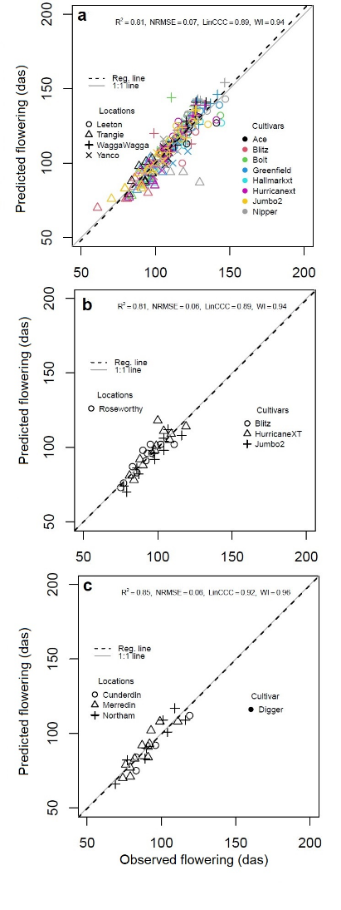

**Supplementary Fig. 1**. Observed versus predicted days after sowing (das) to flowering in four locations of New South Wales (a), South Australia (b) and three locations of Western Australia (c) after accounting for soil water effects on thermal time accumulation (APSIMw). Cultivars Ace, Blitz, Bolt, Greenfield, HallmarkXT, HurricaneXT and Jumbo2 have a PBA prefix. In Western Australia (c), Digger was the only cultivar grown.

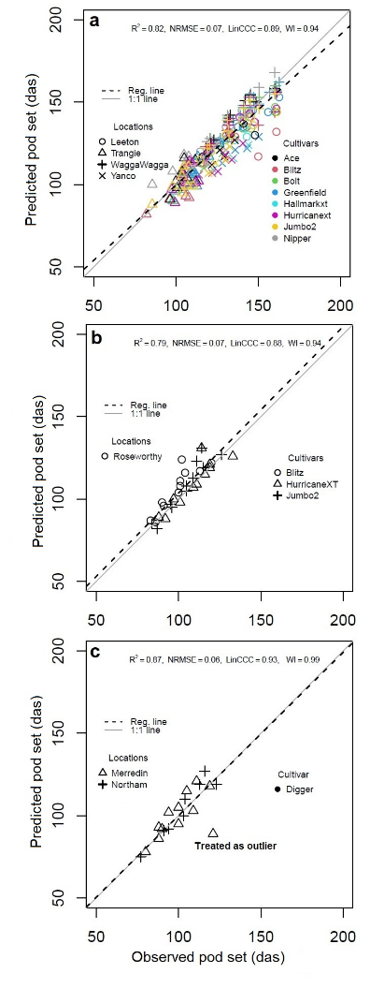

**Supplementary Fig. 2.** Observed versus predicted days after sowing (das) to pod set in in four locations of New South Wales (a), South Australia (b) and three locations of Western Australia (c) after accounting for soil water effects on thermal time accumulation (APSIMw). Cultivars Ace, Blitz, Bolt, Greenfield, HallmarkXT, HurricaneXT and Jumbo2 have a PBA prefix. In Western Australia (c), Digger was the only cultivar grown.

|  |  |  |  |
| --- | --- | --- | --- |
| **Supplementary Table** 1. In-season mean Maximum (MaxT) and minimum (MinT) ambient temperatures, total rainfall across different sowings in eight locations. | | | |
| Location (sowings) | MaxT (°C) | MinT (°C) | Rainfall (mm) |
| Merredin (12) | 20.2 | 7.6 | 186 |
| Northam (8) | 21.0 | 7.2 | 211 |
| Cunderdin (4) | 20.1 | 8.3 | 237 |
| Wagga Wagga (8) | 24.0 | 8.0 | 380 |
| Trangie (8) | 24.9 | 11.7 | 151 |
| Leeton (8) | 24.1 | 10.0 | 241 |
| Yanco (4) | 24.0 | 10.7 | 117 |
| Roseworthy (11) | 22.1 | 8.1 | 237 |