**How to chew gum: the post-ingestion fate of foliar secondary compounds consumed by a eucalypt herbivore**

**Supplementary file 4**

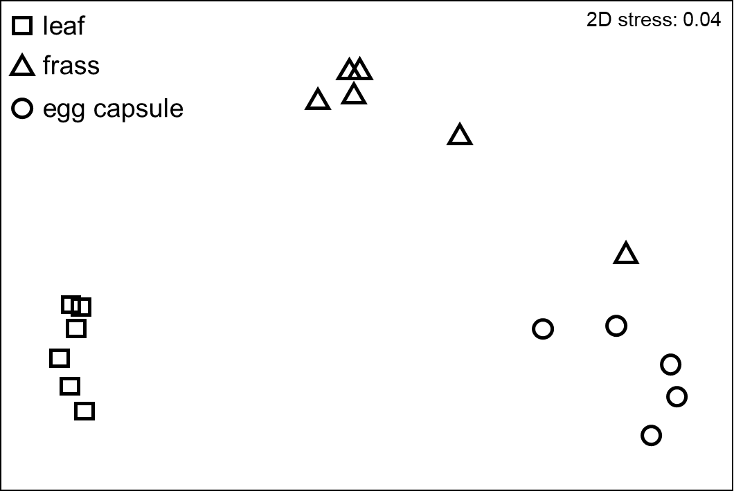

Non-metric multidimensional scaling (nMDS) ordination based on Bray-Curtis clustering of fourth-root transformed data according to sample of *Gonipterus* sp. n. 2 frass, egg capsules and damaged *E. globulus* leaves