**How to chew gum: the post-ingestion fate of foliar secondary compounds consumed by a eucalypt herbivore**

**Supplementary file 1**: Work-flow diagram and Correction factor calculation

Correction factor calculation

Step 1. Area correction factor per sample (CpS), for each retention time

$CpS= \frac{(AEc-AEo)}{Ec}$, where:

AEc = Area, concentrated extract, and

AEo = Area, original extract

Step 2. Plot of mean correction for each retention time

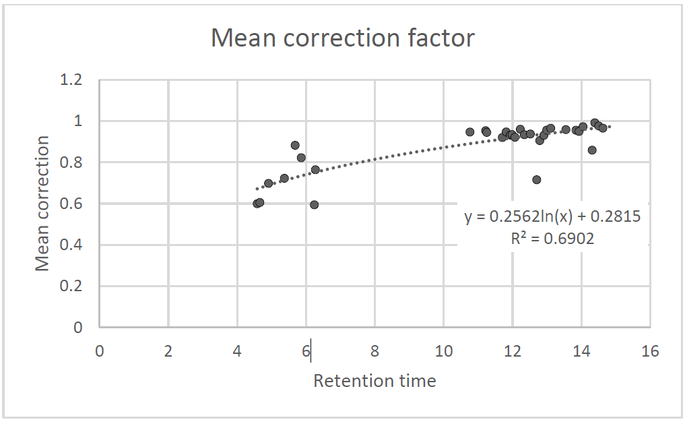

Step 3. Calculate adjusted correction factor for each retention time and apply to each area:

$CA=AEc×\left[0.252\ln\left(RT\right)+0.285\right],$ where:

CA = corrected area, and

RT = retention time